Accessing the Patient Portal for a Telehealth visit

Once you have made your Telehealth appointment with a representative at Main Line Allergy, follow these instructions to set up your Virtual Visit.

- Go to www.mainlineallergy.com homepage to access the Patient Portal.
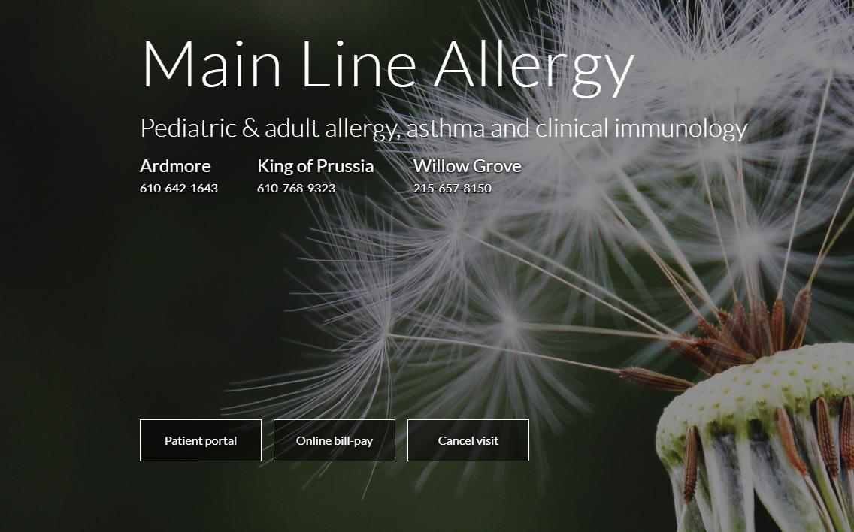

- Log into the Patient Portal with your username (email or cellphone #) and your password.
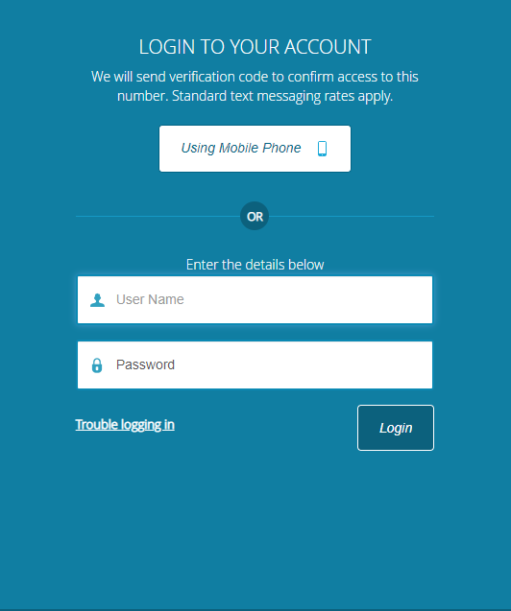

- Once logged in, your dashboard will look similar to the image below.
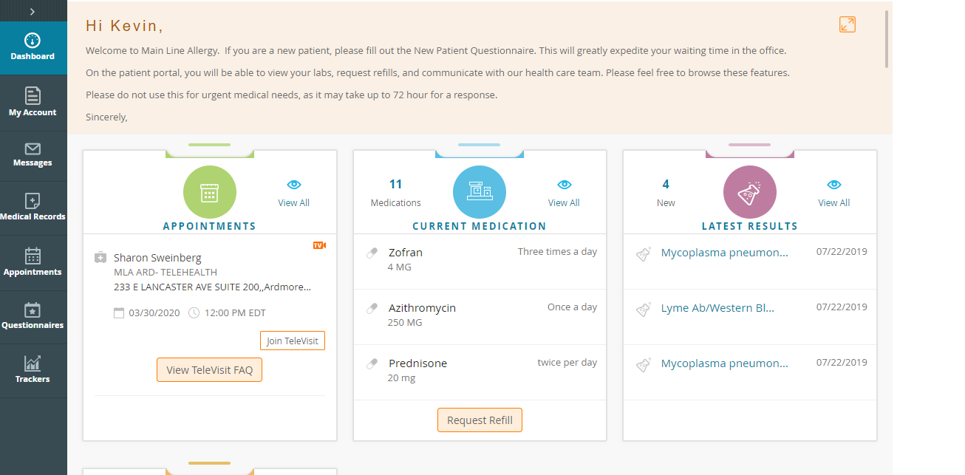

- Under appointment, click on “Join Televisit”.

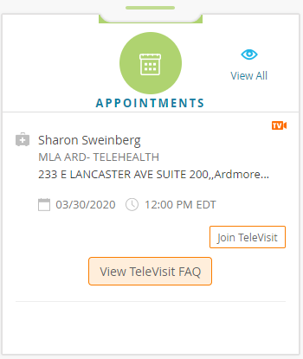

- Once you have joined the visit, you will be prompted to fill out your vitals. Please enter your last known height and weight in the appropriate boxes. Once completed, click “Submit Vitals”.
(if height/weight not known, leave blank, and click “Submit Vitals”).

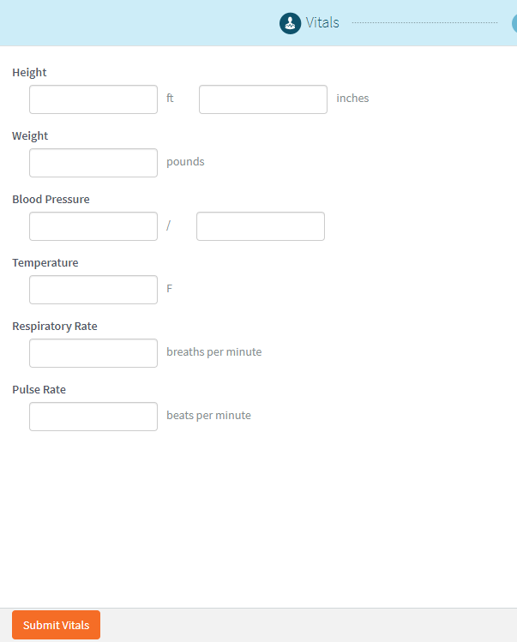

- When vitals are submitted, you will then move to the compatibility check. Telehealth will prompt you to “Allow” their usage of your computer’s microphone and camera. Click “ALLOW” (not deny). This allows you to speak to and see the doctor through video chat. After you click “Allow”, you will see a compatibility check occur. See image below for reference.
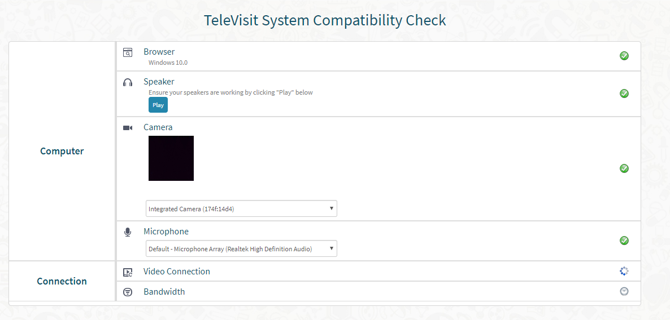
As the system checks that your device is compatible, you will notice a blue scrolling wheel that appears next to the individual categories that are still being verified, and green checks next to categories that have been verified.

If a category appears with a yellow triangle, or a red “X”, this means something went wrong and/or that feature may not be available on your device. If this shows up under the “Connection” area, please check your Wifi and ensure you have a strong connection. If errors continue to occur, please call our office (see image below).
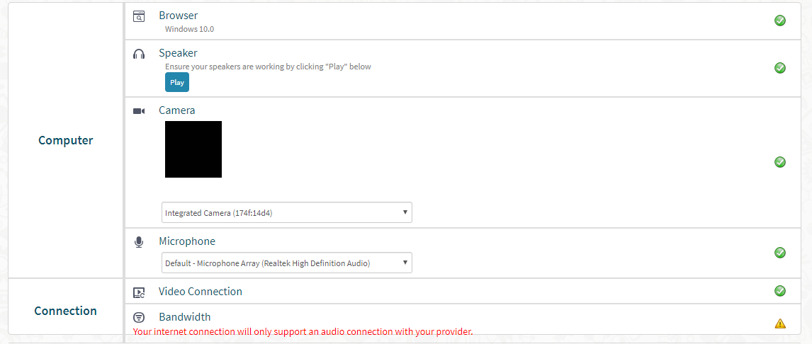

- (continued) Once you have completed the compatibility check, then click “Proceed”.

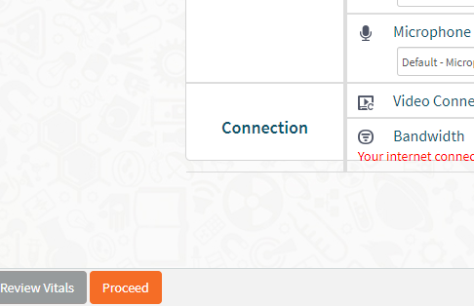

- Here you will wait for your Televisit to become open for you to join (See Image 1). The orange time counts down to 15 minutes before your appointment time and the “Start Televisit” button will turn orange (See image 2), indicating you can start the visit. NOTE: you should join the Televisit at least 15 minutes prior to the appointment, so as soon as the button turns orange, click it.

Image 1
Image 2
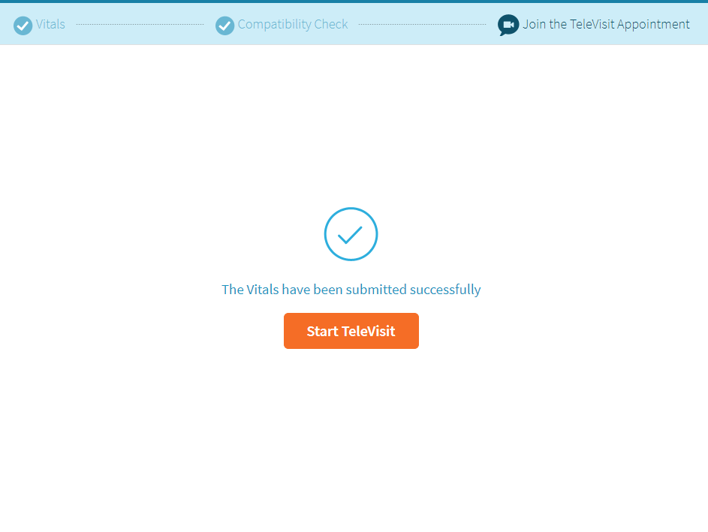

- After clicking “Start TeleVisit”, you be place in a virtual waiting room, until the doctor joins the call. The screen will be black and have a box in the middle that says waiting for Dr._________

- If you are forced to exit the visit or close the screen, you will be brought to the screen below to rejoin the visit. Note: this may cause some technical difficulties with the call, so if possible do not exit the call once inside.
