Changing your password and accessing the Patient Portal

- Speak to a representative at Main Line Allergy have your password reset. Be sure to write down the email they have for you on file to ensure you have your accurate login information. If need be, they can change your email at this time as well.

- Go to Mainlineallergy.com and click on the button entitled “Patient Portal”
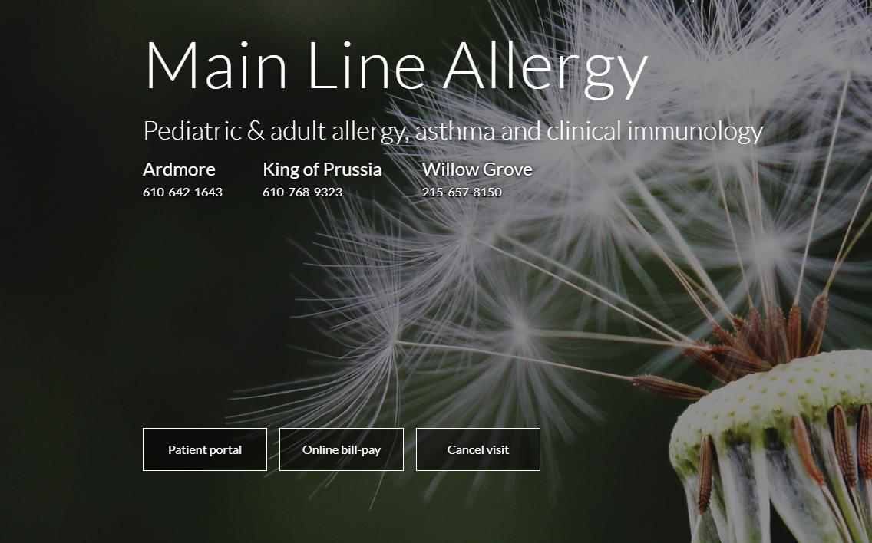

- Once you have selected the patient portal, login with your email, and the password given to you by the representative at MLA
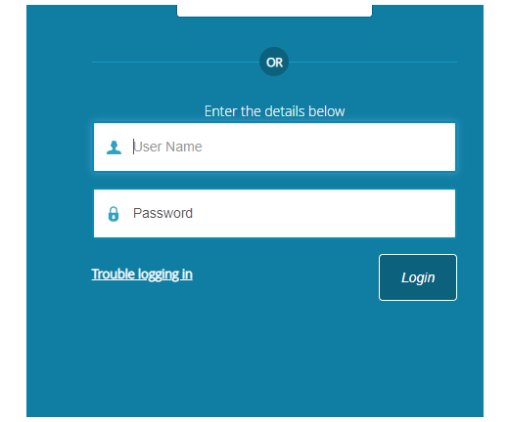
- Follow the prompts to verify your identity. If you have not set up these security codes, simply use your Date of Birth.
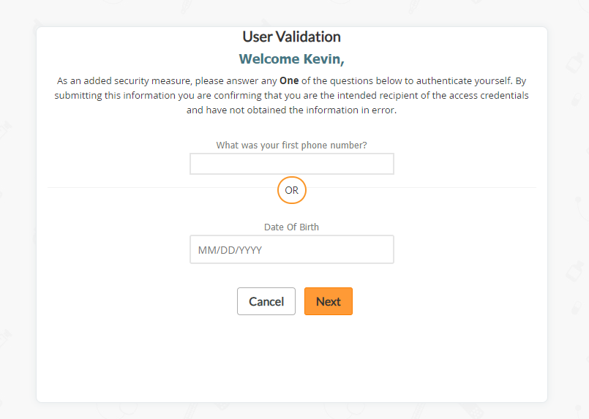

- If you have not set up a security question, the next screen will prompt you to do so.
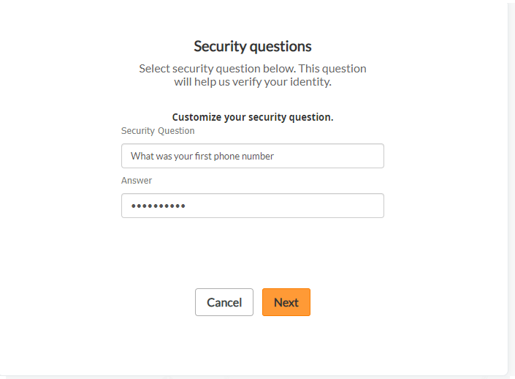

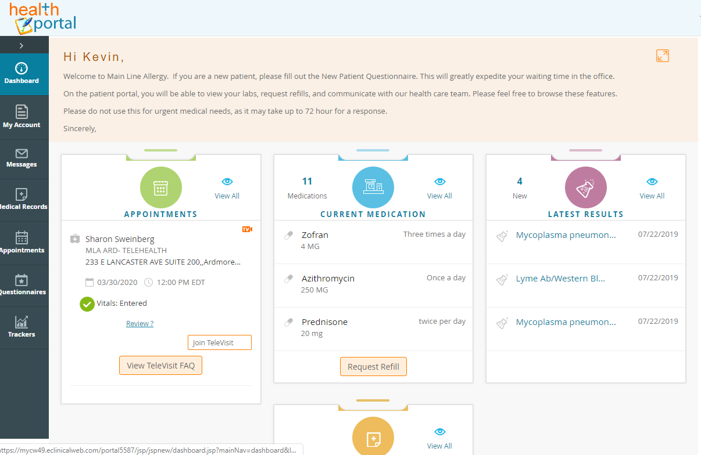
- Once you have updated your security questions you will be brought to the portal homepage.

